**Engro Foods (Pvt.) Limited**



**TO WHOM IT MAY CONCERN**

It is certified that Mr. <Name> S/o <fname> has worked in this organization as an <Designation> at the same project from <From> to <To>.

During his duties with us we found him very hardworking, obedient & capable person. He leaves no stone unturned in performing his duties.

We wish his success in his future career.

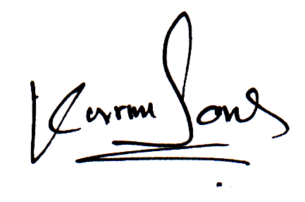

Project Manager

A-110, Sindhi Co-operative Housing Society, Airport Road, Sukkur, Pakistan Tel: 071-5633237-40 Fax: 071-5633241